Name : Shirsath Sanket Dilip Roll No: 69
Class : TE Div : B Branch : COM
Assignment : Virtual Assignment 2
Title : Peer to Peer Topology
Aim :
- To construct Peer to Peer Topology
Theory:
The word physical network topology is used to explain the manner in which a network is physically connected. Devices or nodes in a network get connected to each other via communication links and all these links are related to each other in one way or the other. The geometric representation of such a relationship of links and nodes is known as the topology of that network.
These topologies can be classifies into two types:-
1. Peer to peer
2. Primary - Secondary
Peer to peer is the relationship where the devices share the link equally. The examples are ring and mesh topologies. In Primary - Secondary relationship, one device controls and the other devices have to transmit through it. For example star and tree topology.
Features of Peer to peer:-
- In peer to peer architecture every node is connected to other node directly.
- Every computer node is referred as peer.
- Every peer provides services to other peers as well as uses services of them.
- There is no central server present.
Advantages of Peer to peer:-
- It is easy to install and so is the configuration of computers on this network,
- All the resources and contents are shared by all the peers
- P2P is more reliable as central dependency is eliminated. Failure of one peer doesn’t affect the functioning of other peers.
- There is no need for full-time System Administrator. Every user is the administrator of his machine.
- User can control their shared resources.
Disadvantages of Peer to peer:-
- In this network, the whole system is decentralised thus it is difficult to administer. That is one person cannot determine the whole accessibility setting of whole network.
- Data recovery or backup is very difficult. Each computer should have its own back-up system

Procedure:
- The aim is to Create the topology.
- To perform the experiment follow the below steps
- A blank square area would be given which defines the working area
- A series of components would be given
- In order to build a topology first select on the component and then immediately click on the working area to place it
- To draw a line between two components first select the line click on the port of first component and then immediately click on the port of second component
- Once the topology is build then click on the Submit button to test whether the give topology is built correctly or not.
PRE TEST:
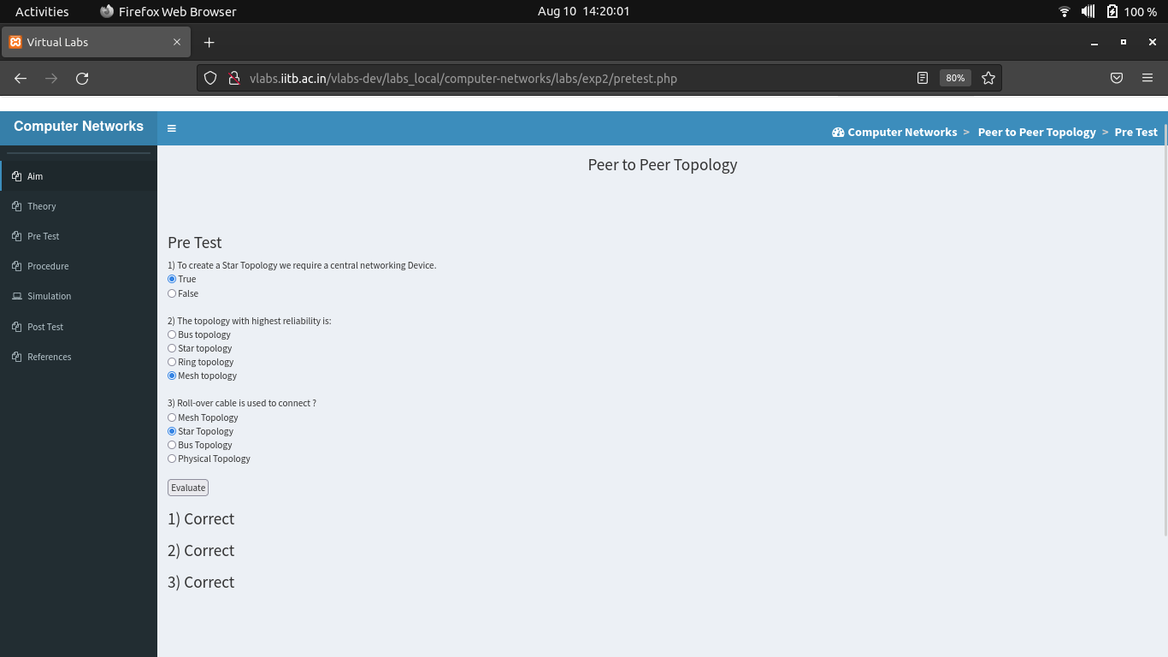
OUTPUT :
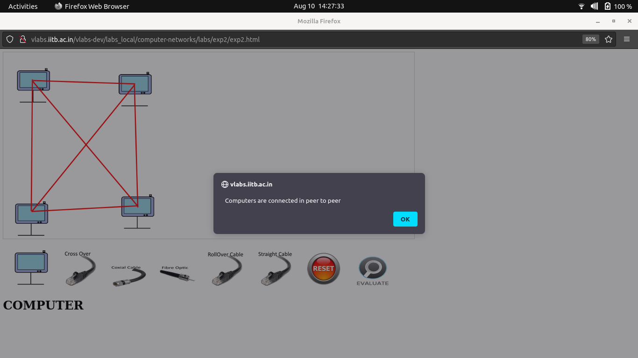

POST TEST:
